Founded in 1962, Taiwan Tai-Hao Ent. Co., Ltd. (URL: www.tai-hao.com) is a very professional keycap manufacturer. We are capable to make various kinds of decent ABS, PBT, POM doubleshot keycaps. In the winter of 2016, we are pleased to introduce our new product: Doubleshot PBT Two-tone Backlit Key Set.

Mechanical Gaming Keyboard is now a very popular computer peripheral. Almost every hardcore gamer have one or even more. For gamers, mechanical keyboard is not merely an input device but also a very important equipment to enjoy the gaming experience. Nowadays most of the gaming keyboards are designed with LED back light, to make the legend distinctive, to make the keyboard fancy and cool. However, the legend on those factory standard backlit keycaps always easily fades after some time of use. Powder coated keys with laser marking legend cannot last long time at all, especially when the user is a hardcore gamer.

To make your beloved gaming keyboard always look brand new and cool, we are pleased to provide you with an ideal solution: Tai-Hao 2016 New Backlit Doubleshot Key Set!

Delicate Doubleshot Legend
Compares with similar product you can find in the market, we are proud to say that we have the most delicate and beautiful legend. With 50 years of experience in doubleshot tooling and injection, we successfully worked out the most ideal doubleshot backlit keycaps for picky gamers who look for best quality.

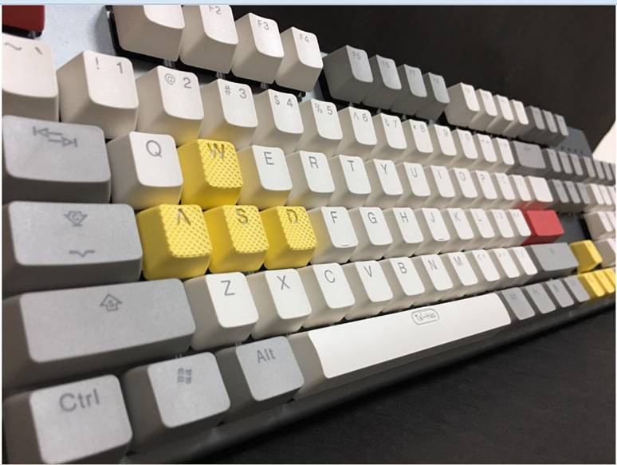
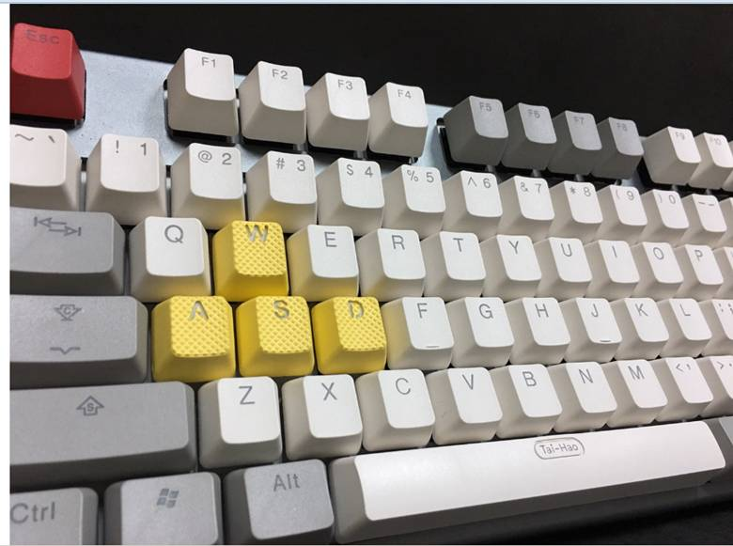

Best Lighting Performance
The most important thing for shine-through keycaps is when the back light is on, how do the legend look. Can the entire legend shine smoothly and clearly? Will I see the light leaking from keytop? These are things that gamers consider most when they plan to buy a baklit keyboard, or a set of backlit keycap.
When you see our product, you will be totally amazed by the lighting performance. No matter the light is on or not, the legend is always very clearly recognizable. And when the light is on, every character is shined silkily without any dark portion, no any leak of light can be found.
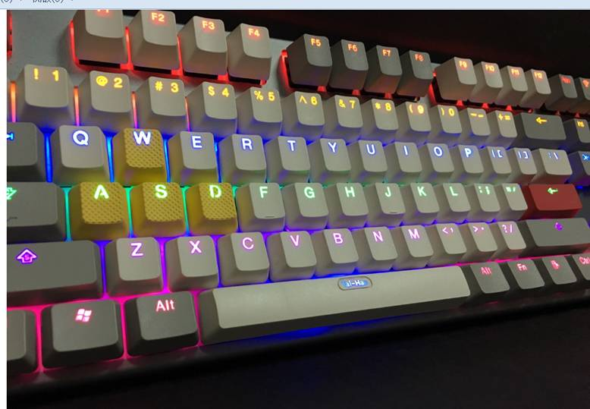

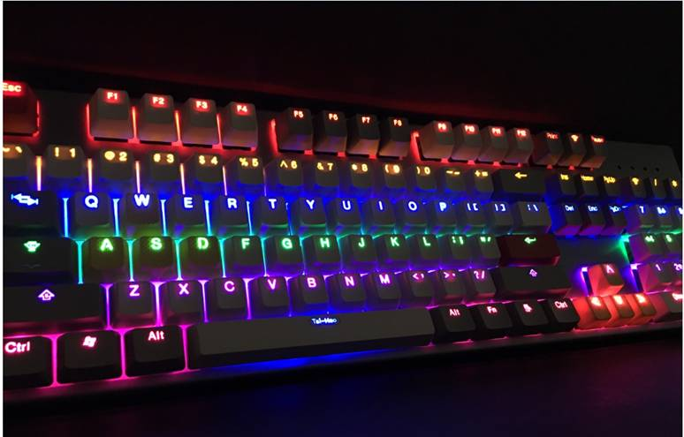
Variety of Colors
Based on the two-tone color pattern, we are able to provide our PBT shine-through key set in various colors. Gamers can choose their varorite one to dress up their beloved mechanical keyboards perfectly. For more informaiton about new color patterns we are developing, please contact us for updates.

Doubleshot ABS Two-tone Backlit Key Set.
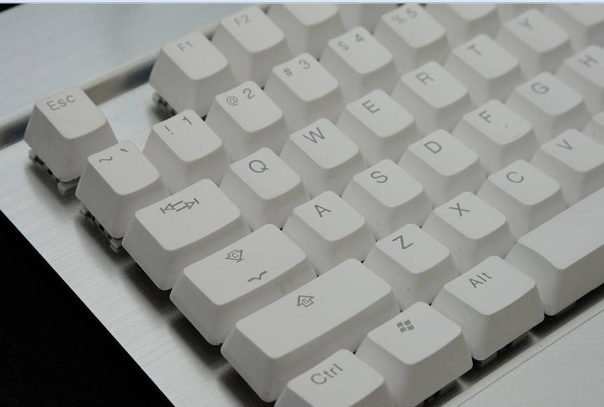

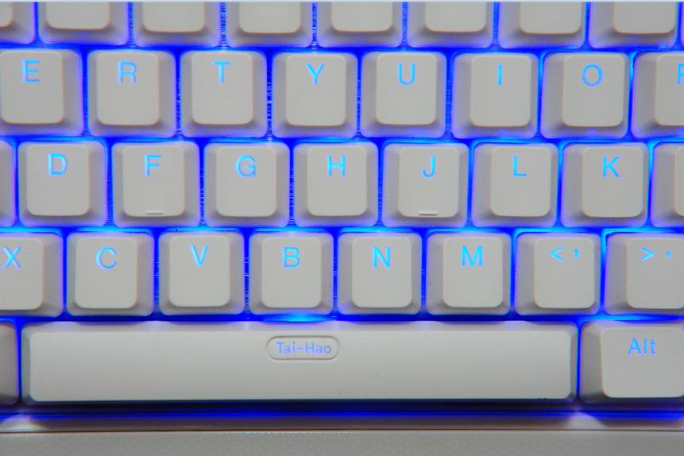
Rubberized Backlit Gaming Key Set

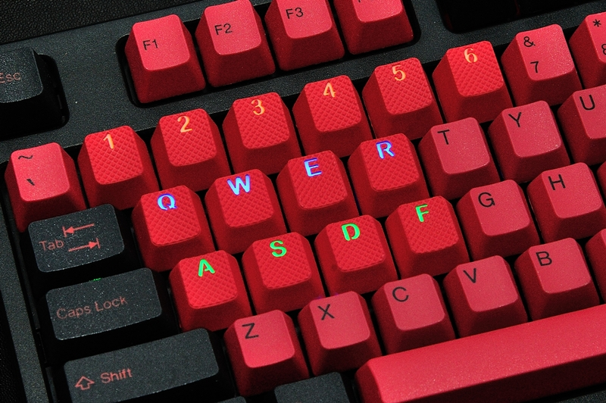

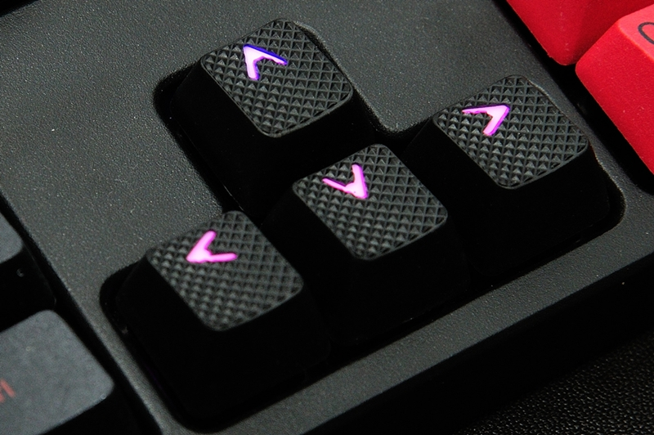
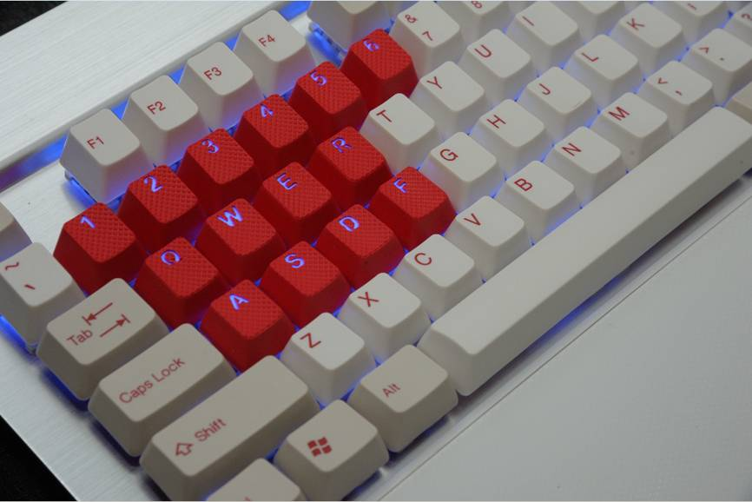
If you are interested in this new key set, please kindly send me an email at ivyhuang@tai-hao.com.tw and I will provide you with detailed product specification together with the quotation sheet. Any questions, please do feel free to let us know. We look forward to hearing from you and cooperating with you in near future!!

Thanks and regards,
Ivy Huang
Taiwan Tai-Hao Ent. Co., Ltd.
TEL: 886-2-27610959 Ext. 12
FAX: 886-2-27669568

